JUnit – a standard unit testing tool for Java programs

- Open source and documentation available at

http://www.junit.org
http://olex.openlogic.com/packages/junit/3.7
- [1,2] describe the Junit 3.x framework by using the following class diagram:

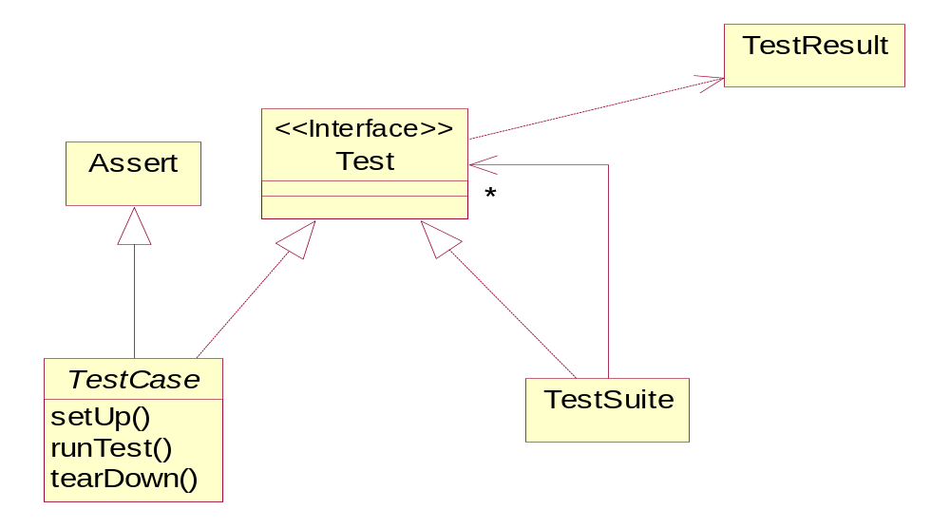

- The design of JUnit is based on the following patterns:
  - Command (test cases are encapsulated and manipulated as objects)
  - Composite (a TestSuite is a composite of TestCases)
  - Template Method (tests are based on a template sequence of operations: each test method is run between a call to setUp() and a call to tearDown())

- To create a test-case class you have to define a subclass of TestCase.
  - Each test-case class may contain several test methods.
  - Each test method is run in a fresh instance of the test-case class.
  - The test-case class may override setUp() and tearDown().
    - setUp() and tearDown() provide control over each test fixture (the set of objects that are involved in a test).
  - Assert provides (static) methods for checking the test values.
- You can write and execute collections of tests assembled in test suites.

- The new versions JUnit 4.x use annotations (require JDK 5 to run): @Before, @After, @Test (for set up, tear down and test methods, respectively).

References

[1] Kent Beck. JUnit pocket guide. O’Reilly, 2004.
[2] JUnit A Cook’s Toor (available from http://www.junit.org)

